CHOICES ACTION FIELD/Referenced value field name/Use source script
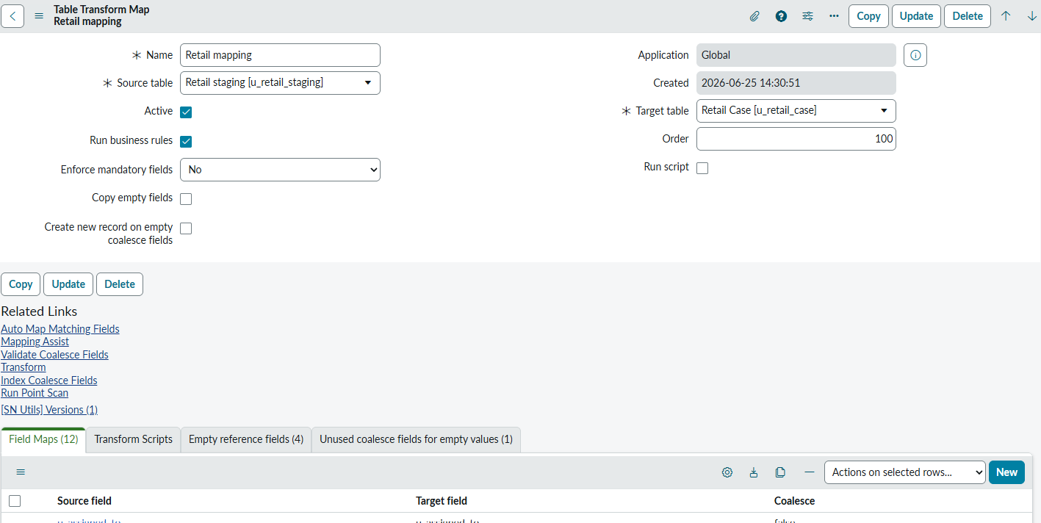

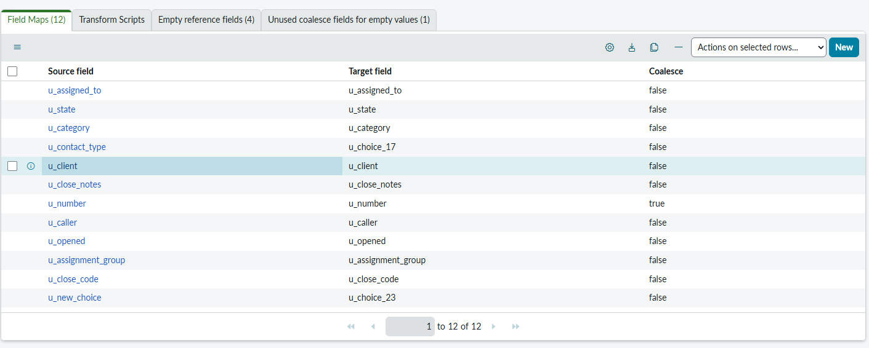

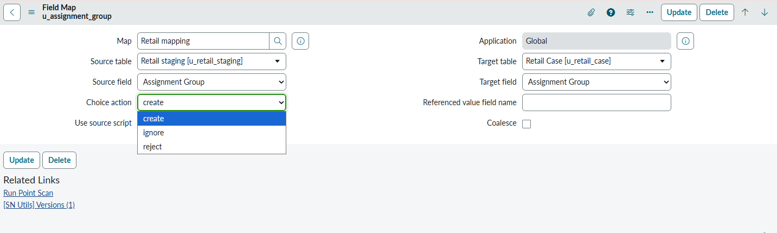

Choice Action: Create Ignore Reject
If we select create: let say assignment Group, now even if the assignment group is not there in SNOW it will get create automatically
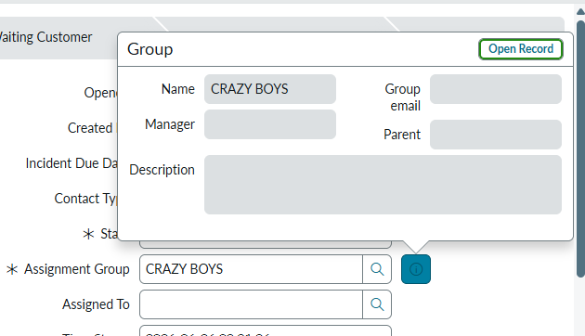

If we select Ignore : It will ignore the particular filed if its not there in the DB and update if any the other fields

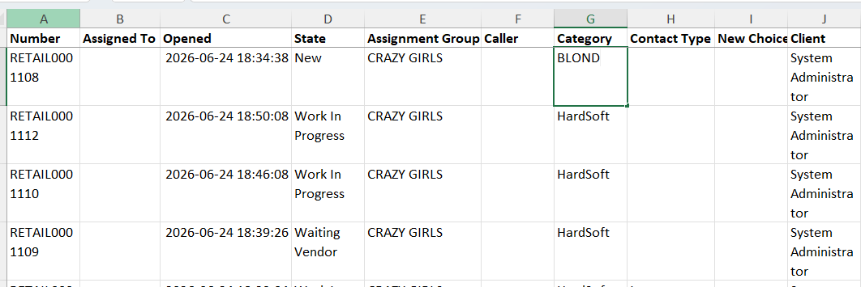

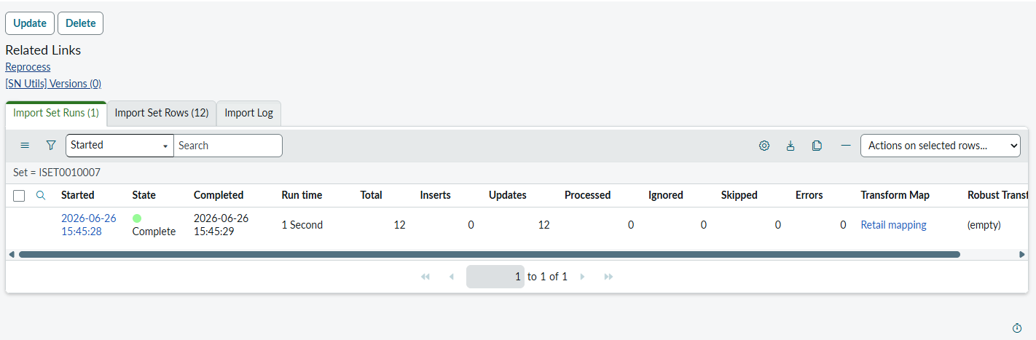

If we select Rejected:


Assignment Group crazy girl is not present in SNOW that means no Update would be done/ the row is skipped
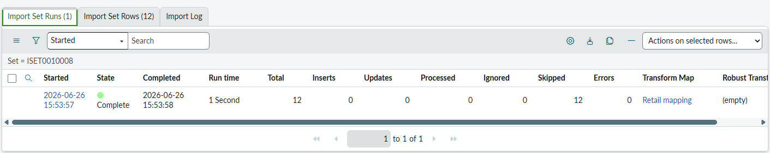
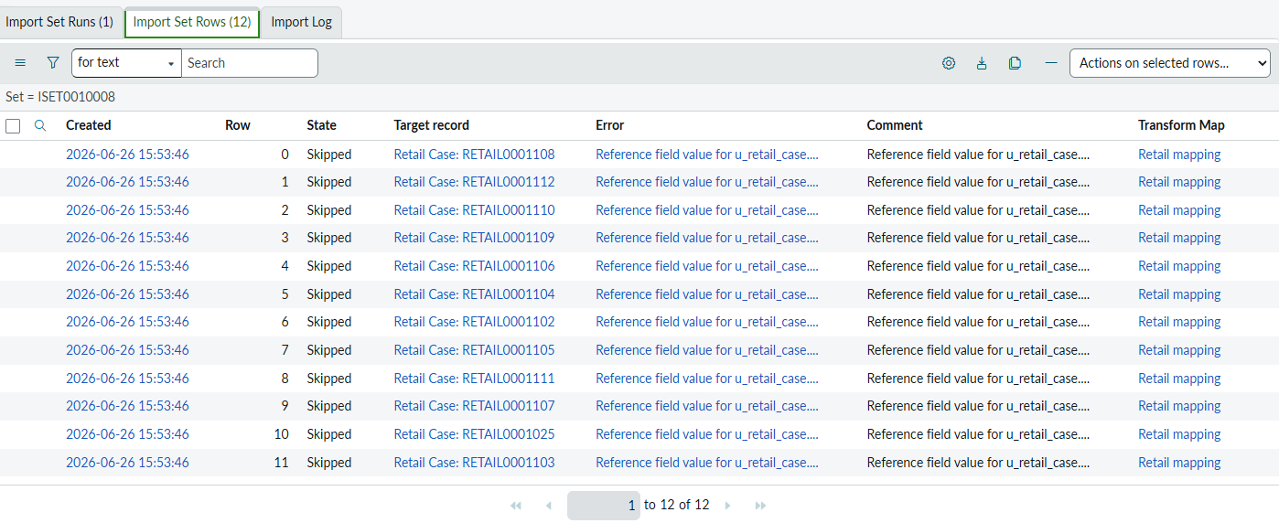

Field Map: Referenced value field name
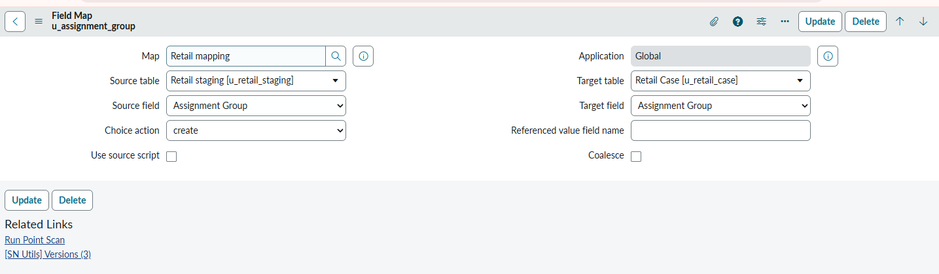

Only available if target Field is a reference field
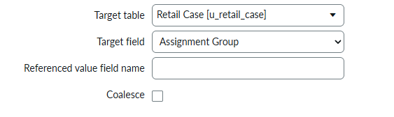
Now in excel we give the Group email let say ‘cg@gmail.com’ in our Assignment group field
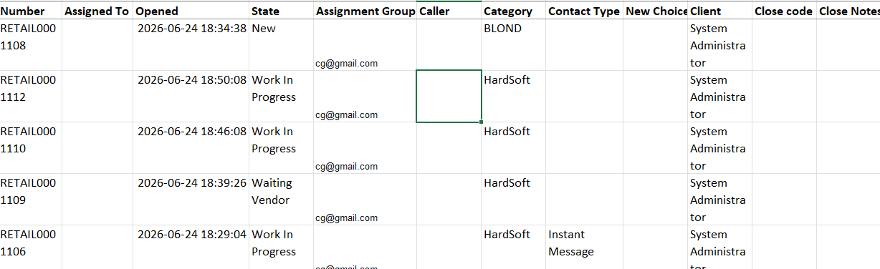

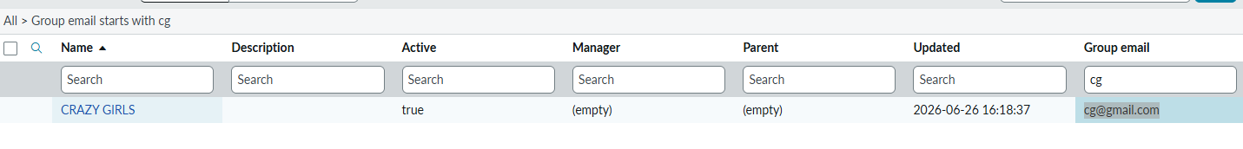
So now the field would be update to CRAZY GIRLS in Table because it can identify the Group using email field
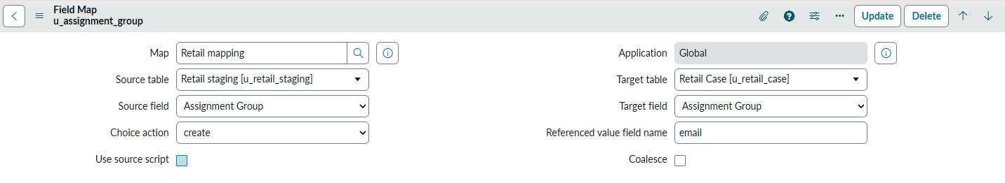
Finally we give the crazy girls the table
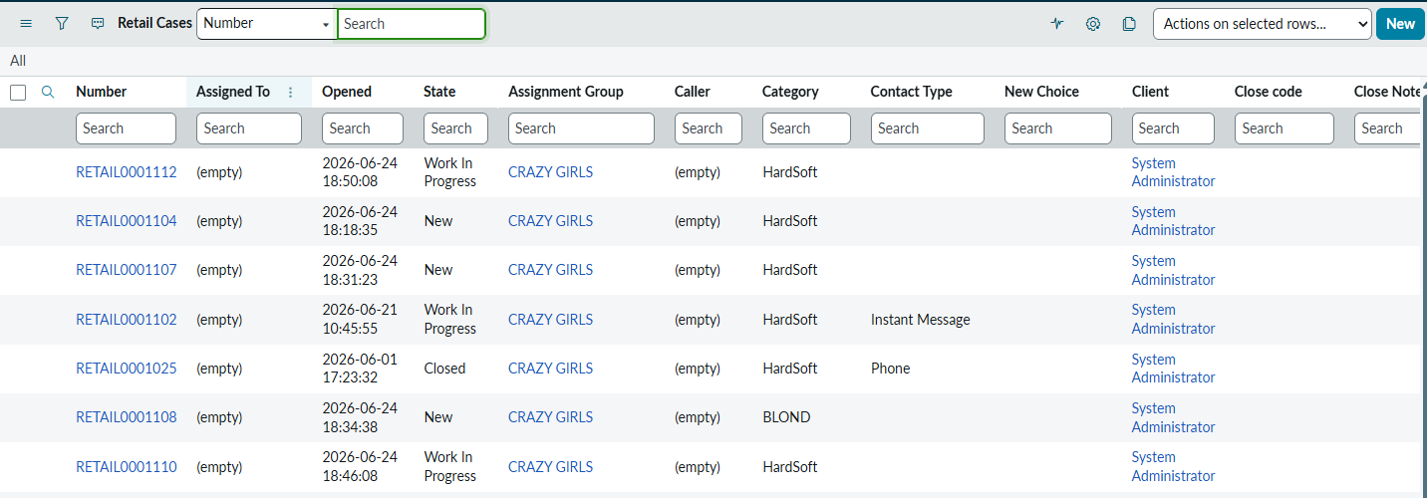

Now is time for Use source script
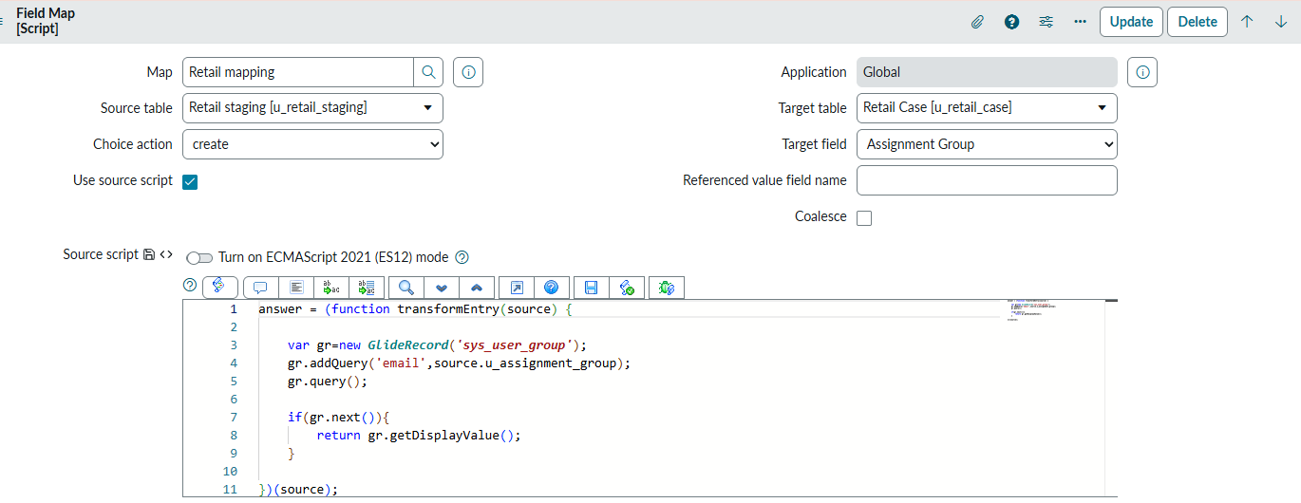

[we are still using email as source group]
It will collect the DisplayValue of the user group and update with that according

Summary:
Choice Action
- Create → Creates the referenced record automatically if it doesn't exist.
- Ignore → Skips only that field; imports/updates other fields.
- Reject → Skips the entire row if the referenced value is invalid.
Example:
- Assignment Group = Crazy Girls
  - Create → Creates Crazy Girls group.
  - Ignore → Assignment Group not updated; other fields update.
  - Reject → Entire row is skipped.

Referenced Value Field Name (Field Map)
- Used only for Reference fields.
- Maps the source value to a unique field in the referenced table (e.g., email).
Example:
- Excel Assignment Group = cg@gmail.com
- Reference Field Name = email
- ServiceNow finds the group with email cg@gmail.com and sets Assignment Group to Crazy Girls.

Use Source Script
- Uses a script to determine the reference value instead of direct field mapping.
- Commonly used to fetch/set the display value or apply custom lookup logic before updating the reference field.

